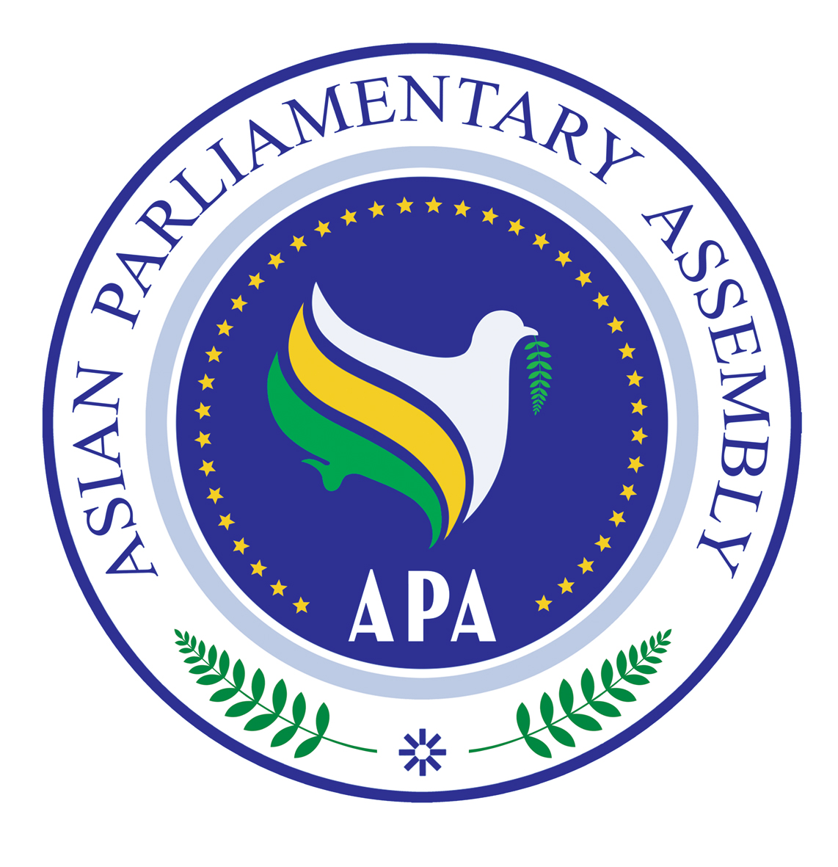
S C/2009/03
18 June 2009

Report of the Sub-Committee
On
Combating Corruption
Jakarta, 18 June 2009

- The Sub-Committee on Combating Corruption met in Jakarta, Indonesia on 18 June 2009. Honorable APA Delegates from Bahrain, Indonesia, the Islamic Republic of Iran, Jordan, Kuwait, Palestine, the Philippines, Saudi Arabia and Syria participated in the meeting. The list of participants is attached as Annex I.

- The Honorable, Mr. Muhaimin Iskandar, Deputy Speaker of the House of Representatives of the Republic of Indonesia made an opening statement on behalf of the APA President. He underlined the importance of the role of parliaments in strengthening anti-corruption strategies at national and international levels. He further emphasized that Corruption erodes quality of life, undermines democracy and the rule of law. Corruption is a key element in poor functioning of economies. Legislation, oversight and participation are the three areas where parliaments can develop an anti-corruption effort. Lack of transparency in election financing is a major problem in Asia. Asia needs to take advantage of opportunities for improvement in this and other areas to combat corruption and promote good governance. The Honorable, Mr. Iskandar supported the efforts of the APA in Combating Corruption and urged further efforts by Member Parliaments to that end. The text of opening statement by Honorable Mr. Iskandar, the Deputy Speaker of the House of Representatives of the Republic of Indonesia is attached as Annex II.

- The Sub-Committee then proceeded to adopting its Agenda.

- The Sub-Committee elected its bureau. The Honorable, Mr. Abdillah Toha, Chairperson for Inter-Parliamentary Cooperation of the House of Representatives of the Republic of Indonesia was elected as the Chairperson. The Honorable, Mr. Matias V. Defensor, Jr., Chairman of the Committee on Justice from the House of Representatives of the Republic of the Philippines was elected as Vice-Chairperson. The Honorable, Mr. Mohamed Yousif Al-Mizal, Member of Council of Representatives of the Kingdom of Bahrain was elected as the Rapporteur.

- The Chairperson made a statement. Honorable, Mr. Toha, pointed out that corruption is a problem everywhere in the world and the difference is only at the level of corruption which each of us is facing with; corruption is a disease that negatively affect every aspect of our lives. A clean and good government is our objective to allow us to fulfill our obligations and achieve the goals we democratically set for our national efforts. Honorable, Mr. Toha emphasized the need for APA Member Parliaments to take steps to implement the Plan of Action and to exchange views with one another to learn about the national experiences of other Member Parliaments.

- His Excellency, Mr. Bibit Samad Rianto, the Vice Chair of the Corruption Eradication Commission of Indonesia was invited to make a key-note speech. H. E., Mr. Rianto expounded on the Indonesian experience with corruption and the manner in which Indonesia is dealing with it with a view to eradicating it. He expressed support for the efforts of APA, particularly those in areas of legislation, to combat corruption. He pointed out that Indonesia is a member of the UN Convention against Corruption and that it has been legislated into domestic laws. KPK, Corruption Eradication Commission of Indonesia, an independent body, has a wide mandate for investigation and prosecution of corrupt acts by law enforcement and public officials. KPK also engages in public education about anti-corruption efforts. H. E., Mr. Rianto presented some figures about activities of KPK and stated that KPK needs to further enhance its capacities to deal with complaints it receives. The presentation of H. E., Mr. Rianto is attached as Annex III.

- The list of documents before the Sub-Committee included:

- SG/Rep/2009/06, dated 31 May 2009, Follow up Report of the Secretary-General on Combating Corruption,
- SG/Rep/2008/08, dated 20 September 2008, Report of the APA Secretary-General on Combating Corruption,
- APA/Res/2008/18, dated 29 November 2008, Resolution on Combating Corruption,
- APA/Res/2007/05/Annex, dated 19 November 2007, Plan of Action on Combating Corruption.
- H. E. Ambassador Amir H. Zamaninia, APA Assistant Secretary-General presented Secretary-General’s Follow up Report on Combating Corruption contained in document SG/Re/2009/06, dated 31 May 2009. He recalled the APA Resolution on combating corruption and urged Member Parliaments to designate one of their APA delegates as the focal point for coordination of activities, networking and dissemination of information within APA. Mr. Zamaninia also sought guidance from the participants about the institutional framework that needs to be developed within the APA to pursue implementation of the APA Plan of Action on Combating Corruption. He also pointed out that all written submissions in the Sub-Committee may be attached as annex to the Report of the Sub-Committee.

- The Sub-Committee exchanged views on the Report of the Secretary-General. Delegates supported greater effort by APA to combat corruption. Most delegates underlined the importance of the role of corruption-sensitive legislations, like freedom of access to information, code of conduct for parliamentarians and other public officials, witness protection laws and specific laws to promote the integrity of elections, including election campaign financing. Some delegates shared their national experiences with instances of corruption and their efforts to curb it. The delegate from Palestine pointed out that the situation of occupation of Palestine, arrest and imprisonment of forty members of Palestinian Legislative Council have prevented the Palestinian Legislative Council to effectively pursue good and clean governance.

- The written statements presented in the Sub-Committee are annexed as Annex IV.

- The Sub-Committee recommends the following draft resolution to the First Executive Council meeting of 2009, to be forwarded to the APA Plenary for consideration of the Standing Committee on Social and Cultural Issues:

Draft Resolution on Combating Corruption

We, the Members of the Asian Parliamentary Assembly,

Recalling APA Plan of Action on Combating Corruption, contained in APA/Res/2007/05/Annex,

Being concerned with the slow implementation of the APA Resolutions on Combating Corruption in Asia and its Plan of Action;

Recognizing the need of continued coordination and exchange of information as well as best practices within APA Member Parliaments under the framework of the APA Plan of Action on Combating Corruption;

Being alarmed that corruption is an intolerable crime that has negative impacts to public and corporate governance and becomes a serious threat to social and economic development in Asia;

Being aware that efforts in combating corruption shall focus not only on legal prosecution, but also preventive measures;

Reaffirming the determination of APA to combat corruption and to take steps to implement its Plan of Action,

Expressing concern about the problem of corruption that seriously undermines integrity, values and principles of society and the rule of law, weakens public trust and incentive for public participation, and curbs political and economic stability,

Stressing the need to strengthen political will from respective APA executive governments and parliaments in supporting law enforcement duties in combating corruption;

Recognizing the unique role of parliaments to promote accountability, transparency and participation as the three pillars of combating corruption and promoting good governance,

- Welcome the Follow up Report of the Secretary-General on combating corruption contained in SG/Rep/2009/06, dated 31 May 2009;
- Confirm determination to enhance our capacities to further combat corruption, strengthen our anti-corruption strategies, and adopt measures to implement APA Plan of Action to combat corruption;
- Encourage APA Member Parliaments who have not done so, to designate immediately the focal point for development and coordination of anti-corruption programs and activities of the APA as well as dissemination of information;
- Encourage further APA Member Countries to establish a national independent body dealing with combating corruption as part of national anti-corruption policies and strategies;
- Support APA Member Parliaments to intensify socialization of anti-corruption campaigns in their respective countries, particularly through education;
- Urge APA Member Parliaments to enact laws that are related to the behaviors of public officials, general election funding, private sectors, civil society organizations that deal with various humanitarian assistances;
- Call on all Member Parliaments of APA to oversee the processes of privatization in order to ensure the absence of abuse of public funds;
- Reaffirm the importance of implementing operative paragraphs 2,3, 4, 5, 6, and 8 of APA Resolution contained in APA/Res/2008/18, dated 29 November 2008, as a means of exchanging information and enhancing capacity to combat corruption, and express determination to implement them;
- Call on the United Nations to pressure Israel to release more than forty Members of the Palestinian Legislative Council who have been illegally imprisoned and thereby enable the Palestinian Legislative Council to effectively promote good and clean governance;
- Request the Secretary-General to continue to collect information and legislative and regulatory texts from Member Parliaments and relevant inter-parliamentary and non-governmental organizations in order to promote an informed exchange of information and knowledge about effective anti-corruption policies and measures;
- Urge Member Parliaments, relevant inter-parliamentary and non-governmental organization, as well as financial institutions to extend to the Secretary-General their full support and assistance in collection and analysis of corruption-relevant laws and regulatory texts and in implementation of this resolution,
- Also request the Secretary-General to report on implementation of this resolution as well as on an institutional framework geared to making focused progress on implementation of the APA Plan of Action to the next meeting of the Sub-Committee on Combating Corruption.

- The Sub-Committee expressed appreciation to the House of Representatives of the Republic of Indonesia for the hospitality offered to all participants and for excellent organization of the meeting. It also expressed gratitude to the Indonesian APA delegates, particularly to Honorable, Mr. Abdillah Toha, Chairperson of Indonesian Inter-Parliamentary Cooperation for the leadership provided the APA.

